- Conceptual art is when the idea presented by the artist is more important than the finished art.
- Conceptual photography is a type of photography that illustrates an idea.
- - Unknown photographer, concept is integration.
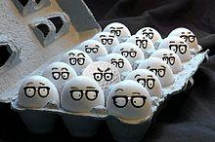
-Hippolyte Bayard, self-portrait as a drowning man
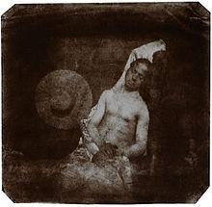
-Sam Samore, Dark Suspicion #1. Woman is supposed to appear as if she resembles someone in a fashion magazine.
